ME 222 LABORATORY REPORT

STUDIES ON REFRACTIVE INDEX (ELLIPSOMETRY)

GROUP NO. – A3

AIM OF THE EXPERIMENT:

Determine the thickness and refractive index of the given sample.

RELEVANT THEORY :

Ellipsometry is a non-destructive, light optical analysis technique that requires neither sample preparation nor special measurement environment. Samples of almost any size and shape can be examined and are unaffected by the process. The non-contact nature of the technique lends itself to measuring materials like semiconductor wafers, optical components like mirrors, coatings, and LCD displays. Ellipsometry uses the fact that light undergoes some change in polarization when it is reflected off the surface of a material. The polarization change is characteristic of the surface structure of the sample and so we can obtain various information about the material simply by analyzing the reflected light beam.

Principle of operation

The principle of operation of an ellipsometer is illustrated by the schematic drawing of the ellipsometer shown in the figure below.

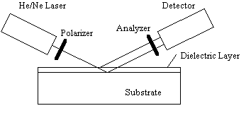

Fig.1 Schematic drawing of an ellipsometer

It consists of a laser (commonly a 632.8 nm helium/neon laser), a polarizer and a quarter wave plate which provide a state of polarization which can be varied from linearly polarized light to elliptically polarized light to circularly polarized light by varying the angle of the polarizer. The beam is reflected off the layer of interest and then analyzed with the analyzer. The operator changes the angle of the polarizer and analyzer until a minimal signal is detected. This minimum signal is detected if the light reflected by the sample is linearly polarized, while the analyzer is set so that only light with a polarization which is perpendicular to the incoming polarization is allowed to pass. The angle of the analyzer is therefore related to the direction of polarization of the reflected light if the null condition is satisfied. In order to obtain linearly polarized light after reflection, the polarizer must provide an optical retardation between the two incoming polarizations which exactly compensates for the optical retardation caused by the polarization dependent reflections at each dielectric interface. Since the amplitude of both polarizations was set to be equal, the ratio of the amplitudes after reflection equals the tangent of the angle of the analyzer with respect to the normal.

Importance: An ellipsometer enables to measure the refractive index and the thickness of semitransparent thin films. The instrument relies on the fact that the reflection at a dielectric interface depends on the polarization of the light while the transmission of light through a transparent layer changes the phase of the incoming wave depending on the refractive index of the material. An ellipsometer can be used to measure layers as thin as 1 nm up to layers which are several microns thick. Applications include the accurate thickness measurement of thin films, the identification of materials and thin layers and the characterization of surfaces.

APPARATUS REQUIRED :

• Ellipsometer main unit

• Polarizer rotation drum

• Laser power supply

• Analyser rotation drum

• Testing sample ( Here SiO2 film on N-SF66 Material)

• Screen

PROCEDURE:

• The laser is powered on.

• The laser arm is positioned in such a way that zero reading of Vernier coincides with the zero of main scale.

• The above step is repeated with the detector arm.

• It is made sure that the beam passes through the centre of the polariser, quarter-wave plate, analyser and detector output.

• The quarter-wave plate cell is removed.

• The polariser angle is set to zero degrees.

• The analyser is rotated to get the null condition.

• The quarter-wave plate is fixed back.

• The quarter-wave plate is rotated until the null condition is obtained again.

• The quarter wave plate is rotated 45 degrees from this position.

• The laser and detector arms are positioned according to incident angle.

• The sample is placed on sample stage.

• The polariser is rotated (270-360) and analyser (0-90) simultaneously until lowest intensity is obtained on screen.

• The polariser and analyser are fine rotated to find null condition.

• The polarizer and analyzer angle are recorded. This is our P1 and A1.

• The polarizer is rotated to (P1 +90) degrees.

• Now the analyzer is slowly rotated between (90-180) degrees and the lower intensity angle is determined.

• The polariser and analyzer are fine rotated simultaneously to find the angles corresponding to the lowest intensity. This is our P2 and A2.

• The software is opened and the values of P1, A1, P2, A2, expected thickness range and the incident angle are entered.

• The thickness range is reduced until the Ψ- ∆ curve reduces to the red point. The corresponding value of thickness is our desired result.

OBSERVATIONS:

Substrate RI = 1.937

Φ0=700

Substrate 1

|  |  |
| --- | --- |
| P1=42.0 | A1=42.9 |
| P2=131.0 | A2=157.30 |

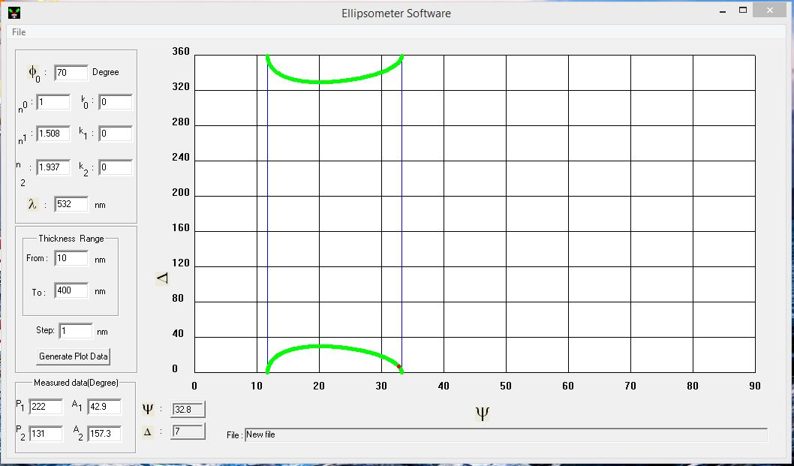

**RI(n) = 1.508**

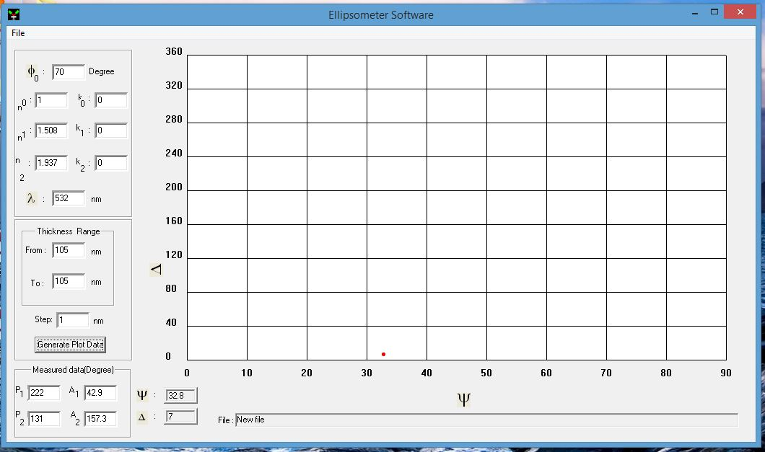

**t = 105 nm**

Substrate 2

|  |  |
| --- | --- |
| P1=32.0 | A1=45.5 |
| P2=122 | A2=346.0 |

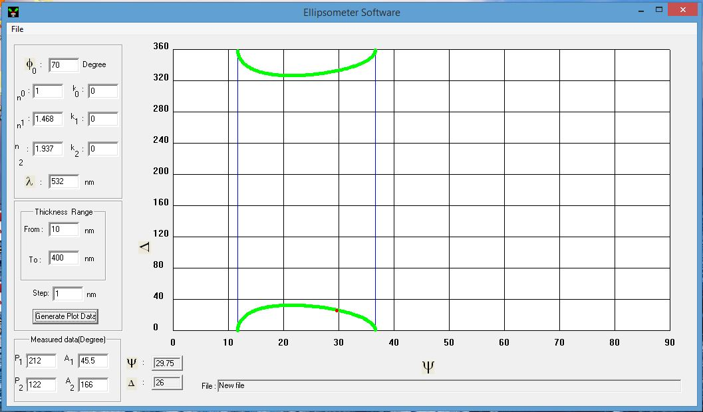

**RI(n)=1.468**

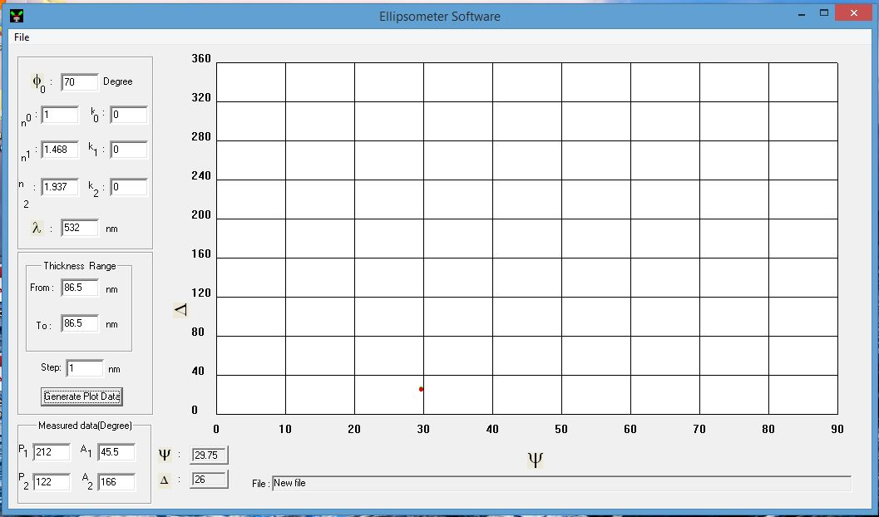

**t=86.5nm**

Substrate 3

|  |  |
| --- | --- |
| P1=59.5 | A1=45.3 |
| P2=148.7 | A2=348.5 |

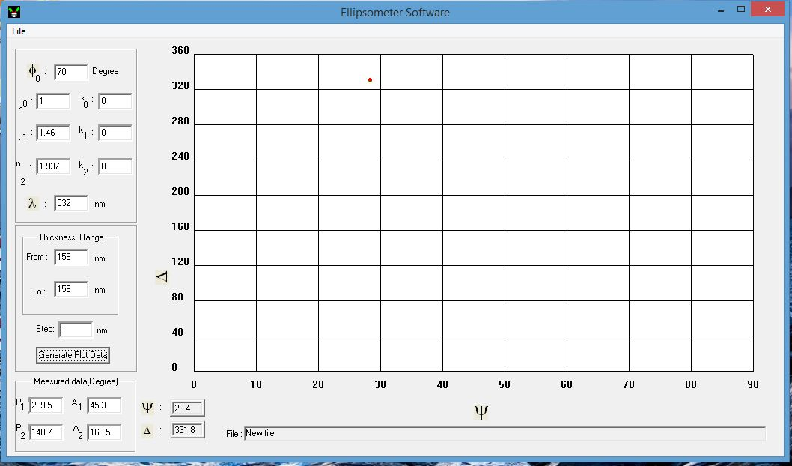

**RI(n) = 1.46**

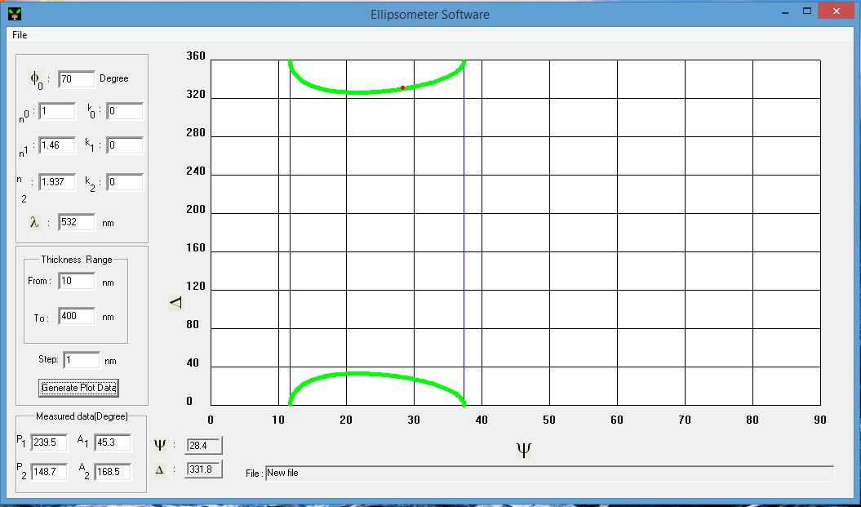

**t = 156 nm**

RESULTS:

|  |  |  |
| --- | --- | --- |
|  | Refractive Index (n) | Thickness(t) (nm) |
| Subs 1 | 1.508 | 105 |
| Subs 2 | 1.468 | 86.5 |
| Suns 3 | 1.460 | 156 |

PRECAUTIONS:

1. It should be made sure that the laser beam passes through the centre of all components.
2. Initial settings should be reset.

REFERENCES:

Wikipedia  
Lab manual